PRINTS-A000-US-Lakota-Kicking Bear-Reinhart-1899

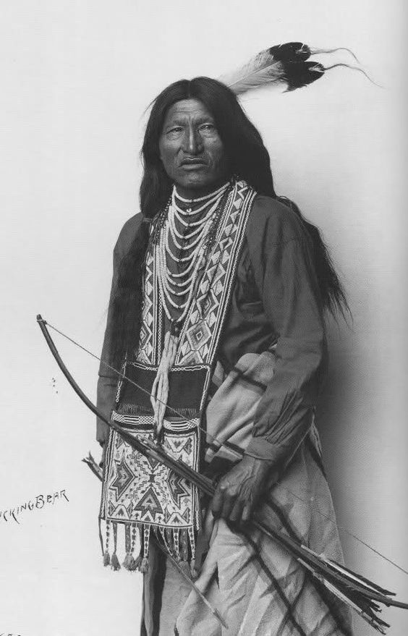

**Chief Kicking Bear Oglala Sioux Warrior Native American South Dakota 1899**

**Photographic REPRINT 6"x4"**

Kicking Bear was a Native American medicine man who was born Oglala Sioux, but became a sub-chief among the Minneconjou Sioux during the period known as the Sioux Wars (1854-1890). Both the Oglala and the Minneconjou belonged to the Lakota Nation. He was a first cousin and close friend of Chief Crazy Horse.

**Less**

**Photo by Rheinhart 1899**